**DAILY ONLINE ACTIVITIES SUMMARY**

|  |  |  |  |  |  |  |  |
| --- | --- | --- | --- | --- | --- | --- | --- |
| **Date:** | **12 July 2020** | | | | **Name:** | **Sana F Habib** | |
| **Sem & Sec** | **6th sem & B sec** | | | | **USN:** | **4AL17CS081** | |
| **Online Test Summary** | | | | | | | |
| **Subject** | | **-** | | | | | |
| **Certification Course Summary** | | | | | | | |
| **Course** | **Python Data Structures** | | | | | | |
| **Certificate Provider** | | | **Coursera** | **Duration** | | | **19 hrs** |
| **Coding Challenges** | | | | | | | |
| **Status: Executed** | | | | | | | |
| **Uploaded the report in Github** | | | | **YES** | | | |
| **If yes Repository name** | | | | [**https://github.com/sanahabib2409199/Sana-F-H.git**](https://github.com/sanahabib2409199/Sana-F-H.git)  **(coding)** | | | |
| **Uploaded the report in slack** | | | | **YES** | | | |
| Applications of python in DA and ML  (Dr .Mohideen  Badhusha) | | | | [**https://github.com/sanahabib2409199/Python-Worshop.git**](https://github.com/sanahabib2409199/Python-Worshop.git) | | | |

Certification Course Details: (Attach the snapshot and briefly write the report for the same)

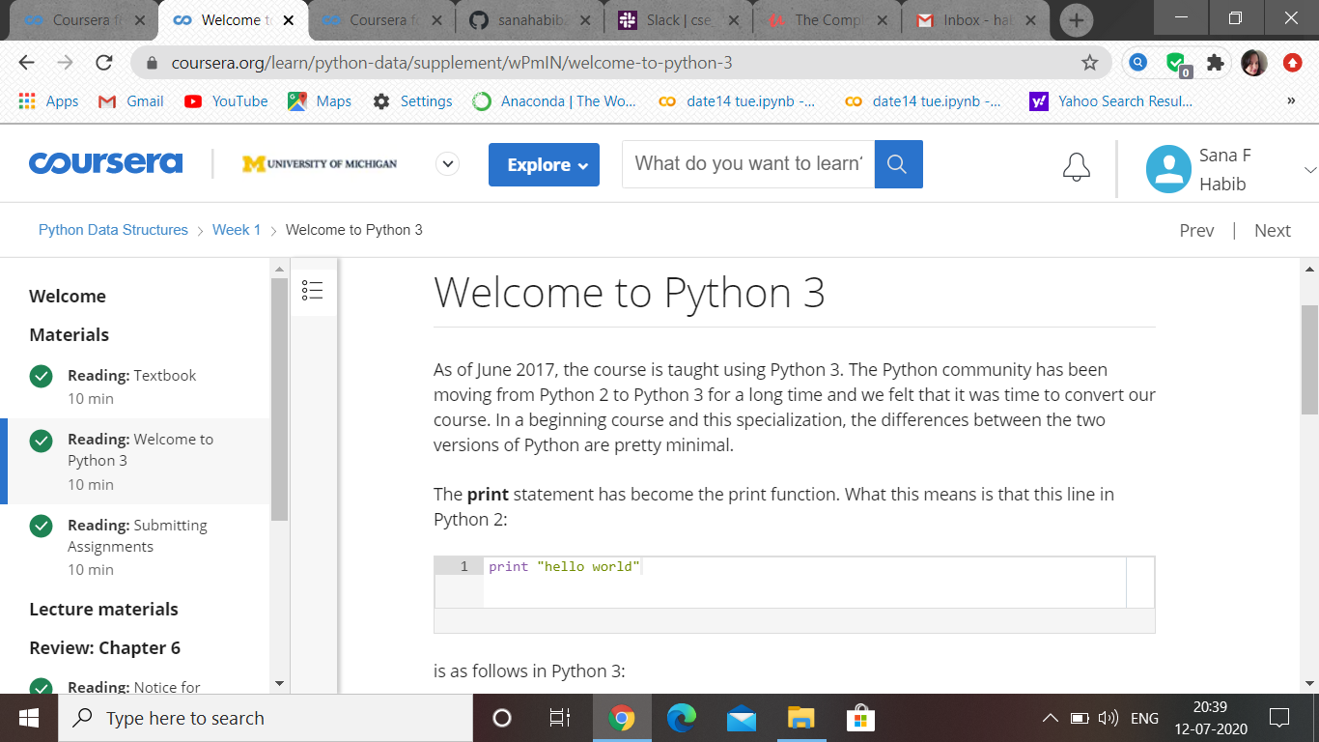

(12-07-2020)-Coursera-Python Data Structures –Week1 …